Company
Procedure Manual
Company Address
Company Phone Number
Company Web Address

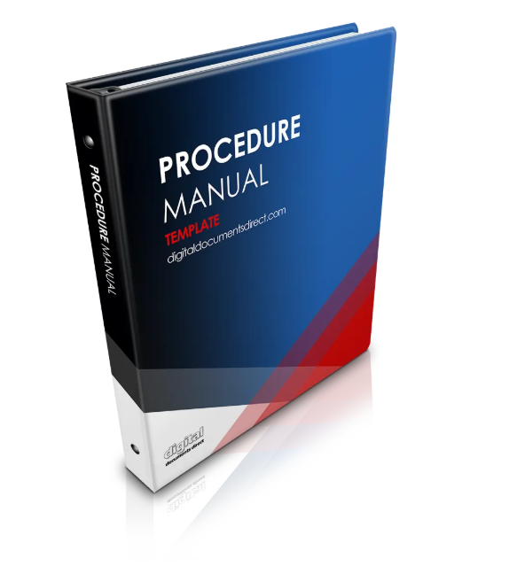

Use Ms Word And Create A Procedure Manual Fast!
Click the link below to read online about our Procedure Manual Template for download. Change the way your business operates faster.
Procedure Manual Template + 44 Free Templates
Click Here to Read More

Our Business 4
Introduction 4
Mission Statement 4
Company Vision 4
Our Values 4
Welcome To Our Business 5
History of This Company 6
Environment and Company Details 7
WORKPLACE requirements 8
Hours of Work 8
Leave 9
Sick Leave 10
Timesheets 11
Procedure Manual Introduction 13
Procedure Manual 13
Procedure – Meeting Room Preparation 14
Procedure Manual Summary 15
Summary 15

Our Business

Introduction
This Policy and Procedure Manual outlines all the ‘Rules and Guidelines’ of our business. As an employee, you are required to follow these rules and guidelines. You should read this document in its entirety and follow these guidelines in your daily work.

Mission Statement

Our Mission Statement:
“At Company , we

Company Vision
The Company Vision is to be a leader in Name.

Our Values
Our employees are the most valued assets of our company, and are essential participants with a responsibility of fulfilling the same mission. We recognize that the motivation and performance of our employees are the key factors in achieving success.

Welcome To Our Business

Dear Employee,
Welcome to Company!
Welcome aboard. We look forward to working with you.
Sincerely,
Your Name
Owner
Director
Operator
Managing Director

History of This Company
Company started in specify.

Environment and Company Details
Address, Telephone and other Details
Company is located at:
Address
The Mailing Address is:
Address
The Post Box Address is:
Address

The Telephone Number is:
T: ADD TEXT

The Facsimile Number is:
F: ADD TEXT

The Company Email Address is:
E: mail@companyName.com

The Company Website Address is:
W: www.Company.com

Your personal email is:
firstNamelastName@company.com

WORKPLACE requirements

Hours of Work
The standard hours of work per day are specify hours plus an hour for a lunchbreak.
It is your responsibility to inform your Workplace Manager of any significant variations to your start and finish times or any periods of leave.
The normal spread of working hours are 8.30 am to 5.30 pm.

Leave
Leave can only be taken when accrued. Notice as far in advance as possible is requested.
Unpaid leave will only be approved at the companies convenience.
To find the location of leave forms please refer to specify.

Sick Leave
If you are going to be away sick, please let the Workplace Manager know directly.
Sick Leave forms are available at Specify Location and are to be filled out on the first day back to work and forwarded to the Workplace Manager to sign.
A medical certificate is required for more than 2 days sick leave.
A medical certificate is required for days either side of a weekend. For example, if you are sick on Friday, you will need to bring a medical certificate to work on Monday.

Timesheets
Timesheets must be filled out on a daily basis.
At the end of each day, all team members are required to enter in their hours for the day in the relevant timesheet.
Every Monday you need to check your timesheet for the previous week, save any changes, and submit it for approval.
You may wish to keep a personal copy of your timesheets and any attached leave forms.
Workplace Managers will file all signed team members timesheets and leave documents centrally on team members personnel files.

PROCEDURE MANUAL

Procedure Manual Introduction

Procedure Manual

This Procedure Manual outlines specific tasks and step by step process you are required to do to get your job done.
As this is quite detailed, you are required to have a copy of this document with you while working.
Should you have any queries regarding your tasks, please refer to this document first and then should you still have further queries, please refer to your Supervisor.

Procedure – Meeting Room Preparation
Task: Prepare the meeting room for use. This task is required to prepare the meeting room for use for any meeting.
Steps to be Completed | Completed
Step 1:
Ensure that all tables are clean. Wipe down the boardroom table.

Step 2:
Check the floor to make sure the carpet is clean. If it requires a quick vacuum, there is a vacuum cleaner located in the storeroom.

Step 3:
Make sure a jug of cold water and glasses are positioned in the middle of the table 10 minutes before the meeting starts.

Step 4:
Ensure there are mints on the table.

Step 5:
Once the meeting is complete, clear the empty glasses and water jugs and make sure the meeting room is ready for the next meeting.

Things to Remember:
You may need to organise the meeting room well before a meeting starts.
Ensure that people advise you well before the meeting so you have enough time to prepare it for the meeting.

Procedure Manual Summary

Summary
This concludes the Procedure Manual. Please keep a copy of this Procedures Manual so you can refer to it on a daily basis.
Should you have questions about your employment, daily tasks or any other questions, do not hesitate to speak to your team leader, Workplace manager or supervisor.
The use of the procedure manual is a requirement to fulfil your position correctly. If you are not following policies and procedures then chances are you are performing your role incorrectly.
It is important as a team that everyone follows the same rules and guidelines so that our work is performed in an efficient manner.
Following the guidelines set out in this procedure and policy manual ensures that or business is competitive and also avoids frustrations from everyone involved.
Should you have any concerns or suggestions on how to improve this quality control document do not hesitate to contact your supervisor.

Use Ms Word And Create A Procedure Manual Fast!
Click the link below to read online about our Procedure Manual Template for download. Change the way your business operates faster.
Procedure Manual Template + 44 Free Templates
Click Here to Read More

